**SCREENSHOT OF THE EXISTING DESIGN:**

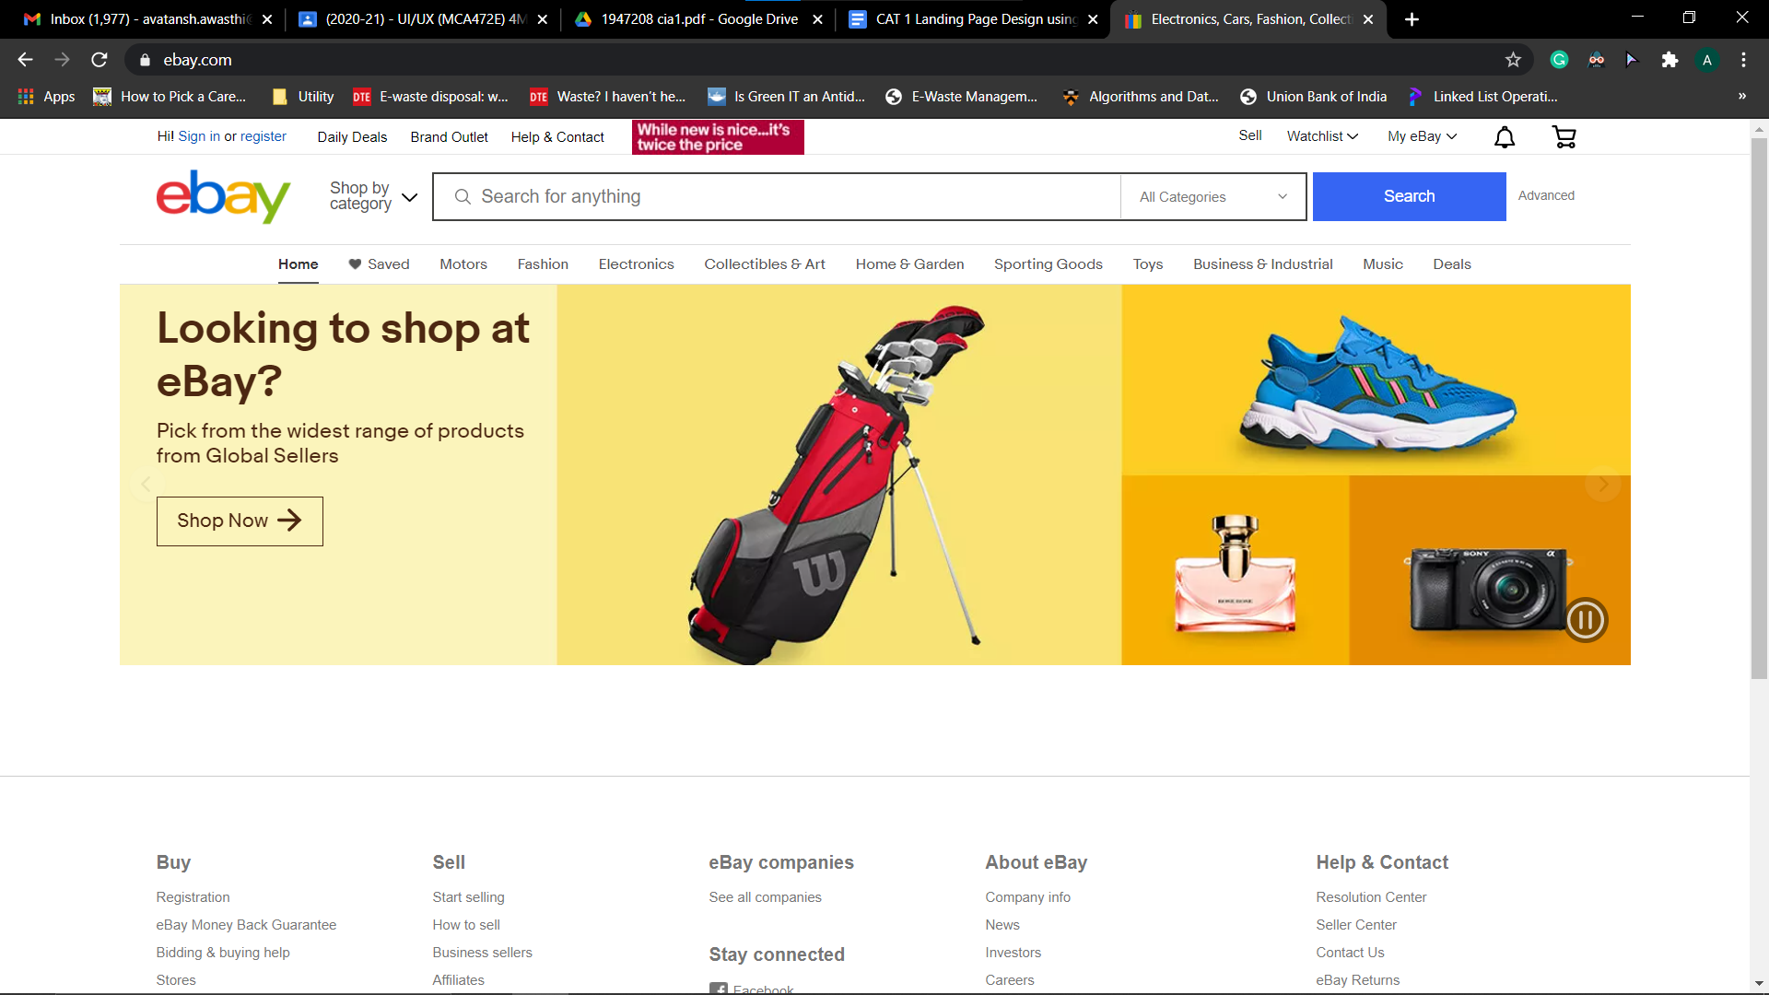

**EXPLANATION OF THE PROBLEM IDENTIFIED:**  Following are the issues distinguished in the chosen site:

Typically the web-based business sites are engaging, which causes the clients to draw in and bound to purchase an item prior to leaving the website.

The textual style and text size are for the most part accentuating however I discovered it to be dull on eBay.

The Signup and Sign-In/Login is generally on the upper right corner with a striking form near to user attention for the simplicity of clients to discover and enlist or sign in to their account.

The web-based business sits for the most part have various areas/sections of items on the point of arrival on landing page, while eBay just has a picture slider along with very minimal text and menus which makes it less captivating.

**TITLE OF THE PROPOSED DESIGN: Ebay.com**

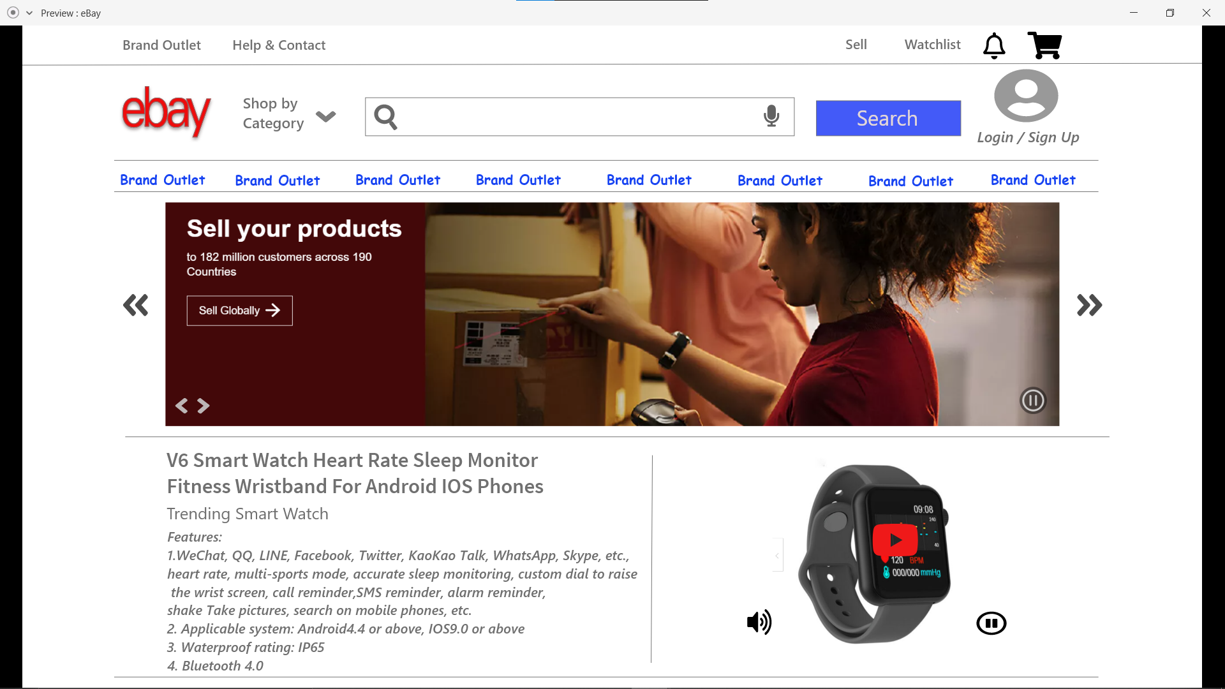

**EXPLANATION OF THE PROPOSED DESIGN:**  Following are the issues recognized in the chose site:

Fusion of more pictures, recordings, and animations for more liveliness to make the site seriously engaging.

Changing textual style and expanding text size for engaging Text on eBay.

Setting up of Signup and Sign-In/Login icon on the upper right corner for the simplicity of clients to discover and enlist or Login to their account.

Execution of various areas of items /sections on the presentation/landing page to make eBay connecting with user, engaging and alluring.

**TITLE OF THE PROPOSED DESIGN: pravaig.com**

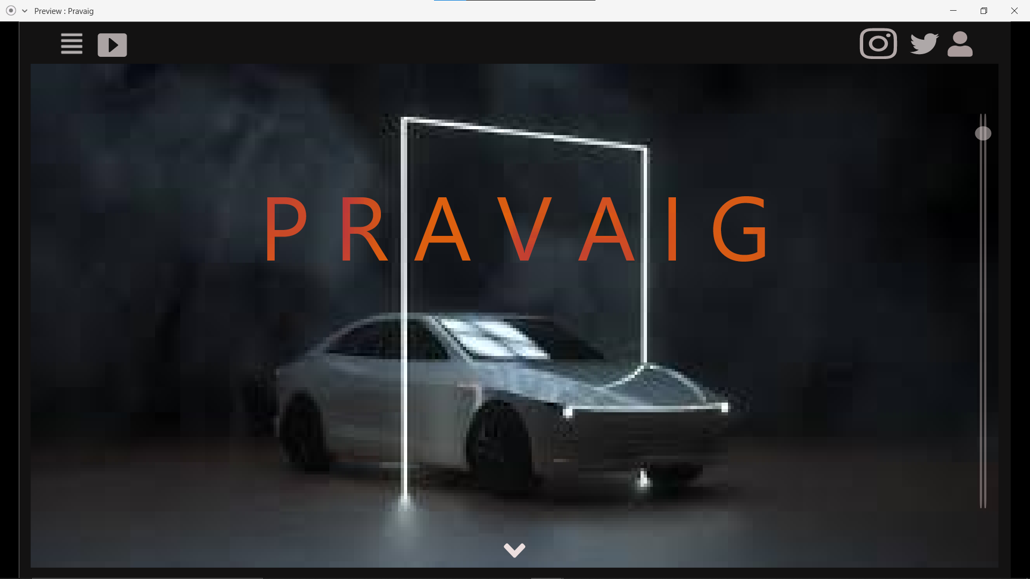

**EXPLANATION OF THE PROPOSED DESIGN:**  The website has to present an immersive look and feel, hence we need to incorporate beautiful pictures especially in the background, also we need to have minimal text and adequate amount of text on the landing page. To do the same we need to eliminate unwanted to excessive text to either next page or we can have menus to have essential information that the user or the customer needs.